**DBMS**

**CREATE QUERY:**

* **CREATING TABLE:**

CREATE TABLE STUDENTNEW(Reg_No number(20), Stud_Name VARCHAR(20),DATE_OF_BIRTH DATE);

**TABLE CREATED:**

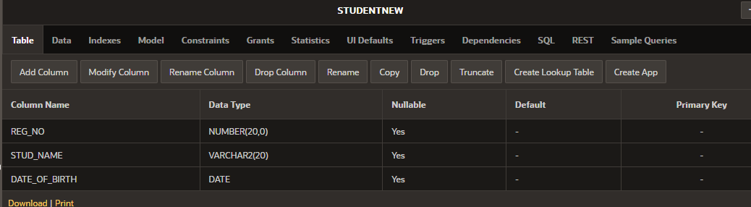

* **ADD THE NEW FIELD TO THE TABLE:**

ALTER TABLE STUDENTNEW

ADD BLOOD_GROUP VARCHAR(6);

**OUTPUT:**

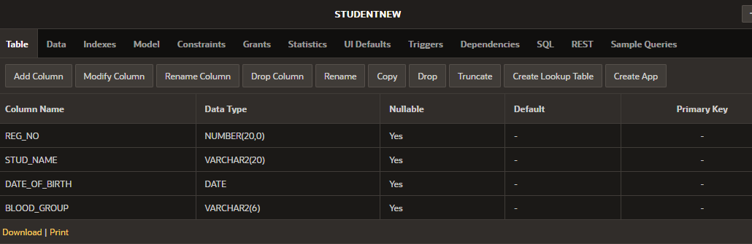

* **TO MAKE THE PRIMARY KEY:**

ALTER TABLE STUDENTNEW

ADD PRIMARY KEY (REG_NO);

**OUTPUT:**

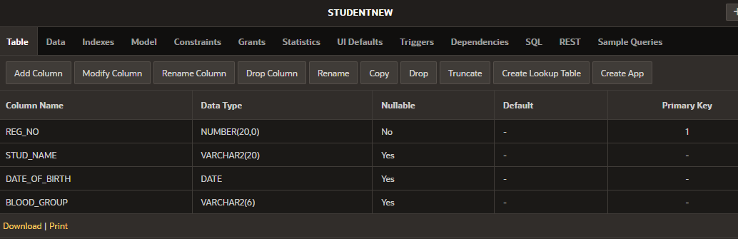

* **DELETE THE COLUMN:**

ALTER TABLE STUDENTNEW

DROP COLUMN MOBILE_NO;

**BEFORE DELETING THE COLUMN:**

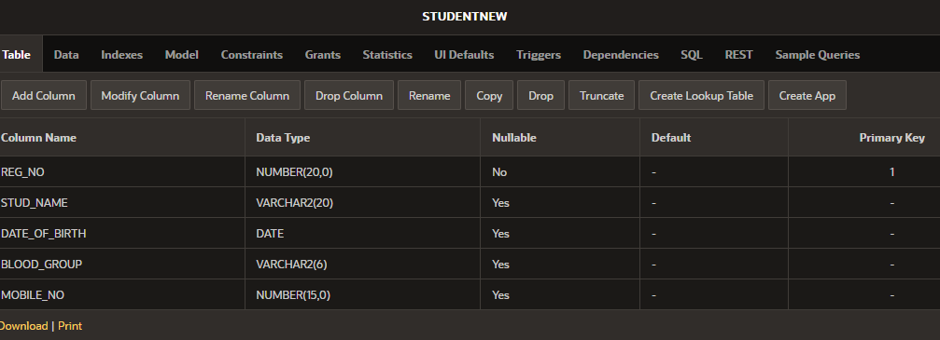

**AFTER DELETING THE COLUMN:**

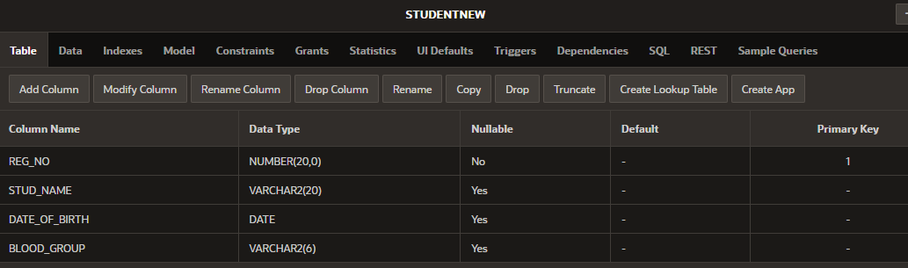

* **RENAMEING COLUMN:**

ALTER TABLE STUDENTNEW

RENAME COLUMN REG_NO TO REGISTER_NUMBER;

**OUTPUT:**

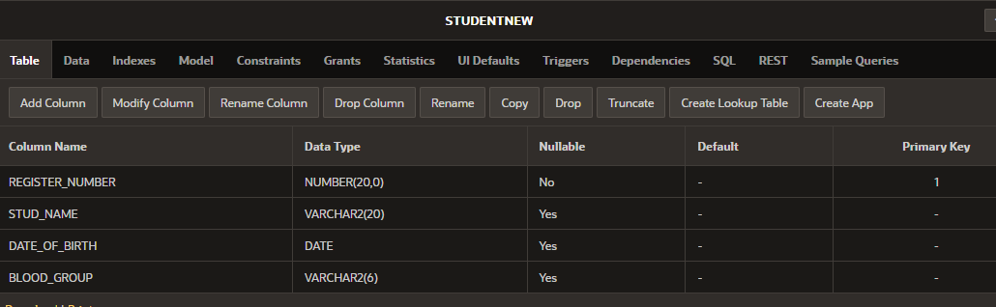

* **MODIFY THE COLUMN DATATYPE:**
* **USING MODIFY:**

ALTER TABLE STUDENTNEW

MODIFY ADDRESS VARCHAR(30) NOT NULL;

**BEFORE CHANGING:**

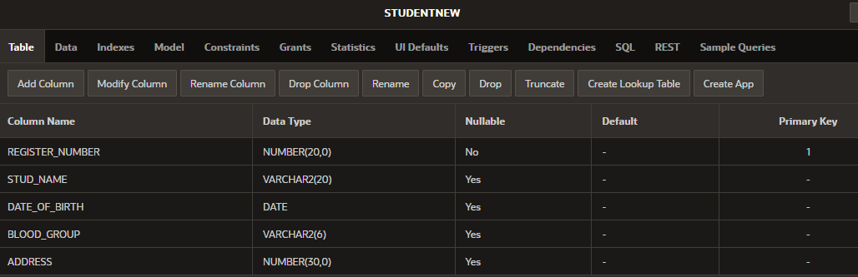

**AFTER CHANGE:**

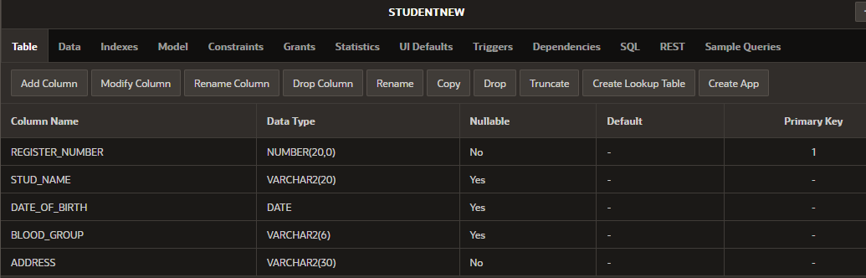

* **INSERTING THE VALUES:**

INSERT INTO STUDENTNEW VALUES(192324118,'PARAMESWARI',SYSDATE,'O','GINGEE');

INSERT INTO STUDENTNEW VALUES(192311143,'DHIVYA',SYSDATE,'B','HARUR');

INSERT INTO STUDENTNEW VALUES(192371030,'SANDHIYA',SYSDATE,'O ','GINGEE');

INSERT INTO STUDENTNEW VALUES(192325049,'HARSHITHA',SYSDATE,'O','AP');

**OUTPUT:**

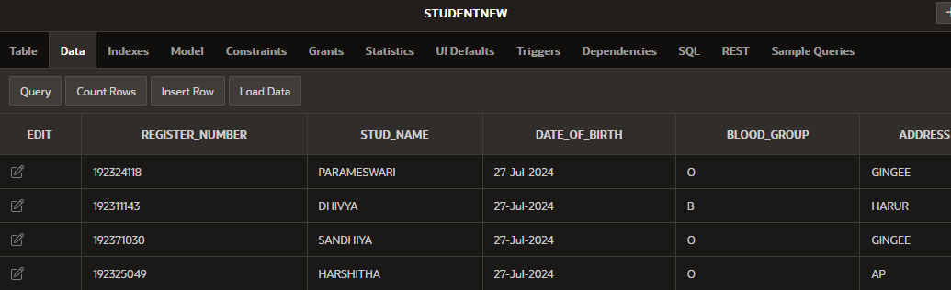

* **DELETE THE COLUMN USING CONDITION:**
* DELETE FROM STUDENTNEW WHERE BLOOD_GROUP = 'B';

**BEFORE DELETING:**



**AFTER DELETING:**

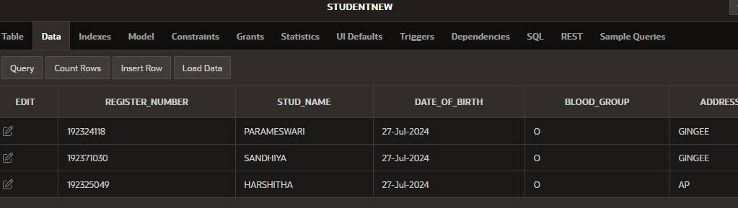

* **DELETING THE DATAS FROM THE TABLE:**
* DELETE FROM STUDENTNEW;

**BEFORE THE DELETING:**



**AFTER DELETING:**

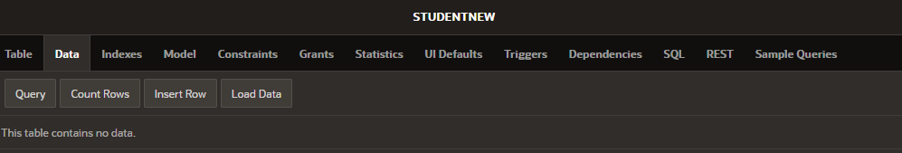

* **DELETING THE WHOLE TABLE:**
* DROP TABLE STUDENTNEW;

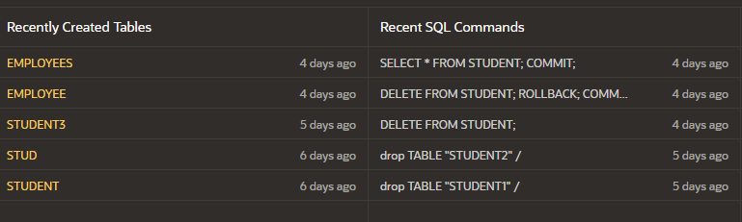

* **SELECT COMMENTS:**
* SELECT THE WHOLE TABLE:

**SELECT * FROM EMPLOYEES;**

**OUTPUT:** 

* USING CONDITION:

SELECT*FROM EMPLOYEES

WHERE SALARY<50000;

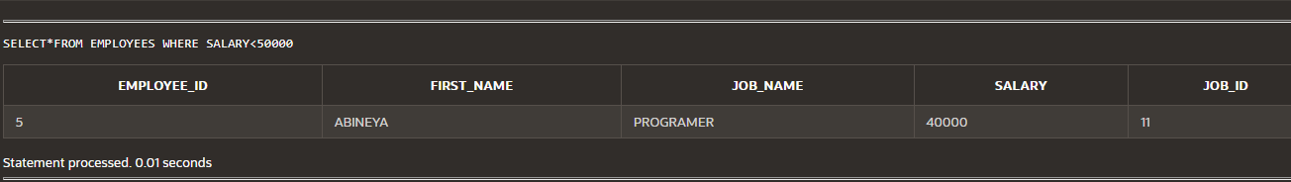

* **DELETE THE PRIMARY KEY:**

ALTER TABLE EMPLOYEES

DROP PRIMARY KEY;

* **BEFORE DELETING THE PRIMARY KEY:**

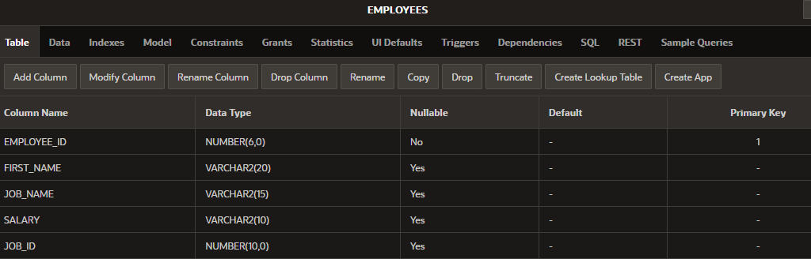

* **AFTER DELETING THE PRIMARY KEY:**

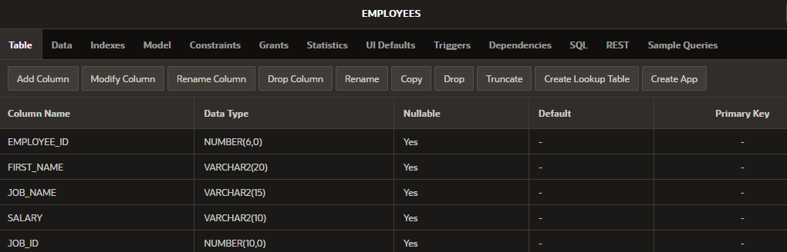

* **SELECT THE TABLE USING “BETWEEN…AND”:**
* SELECT * FROM EMPLOYEES

WHERE SALARY BETWEEN 20000 AND 50000;

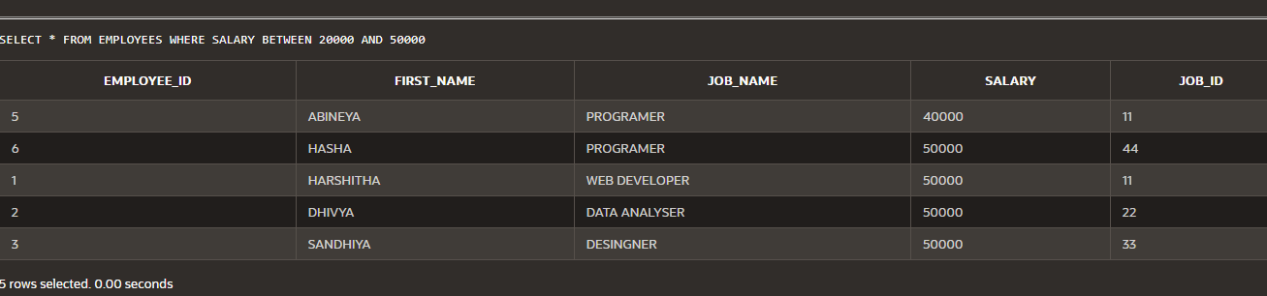

* **SELECT THE UPPERCASE:**
* SELECT FIRST_NAME

FROM EMPLOYEES

WHERE UPPER(FIRST_NAME)='HARSHITHA';

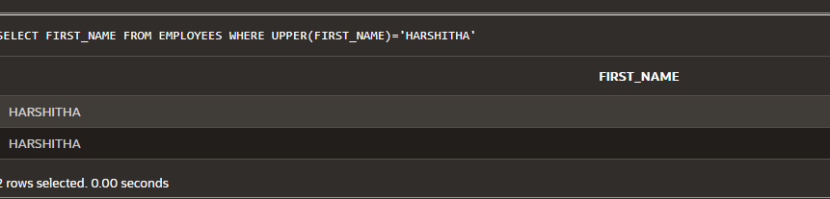

* **SELECT THE LOWERCASE:**
* SELECT FIRST_NAME

FROM EMPLOYEES

WHERE lower(FIRST_NAME)='abineya';

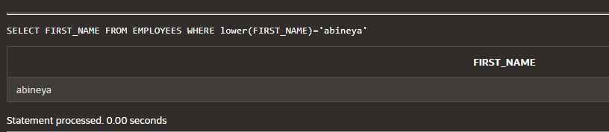

* **SELECT THE TABALE USING “AS..”:**
* SELECT SALARY AS EMLOYEES_SALARY FROM EMPLOYEES;

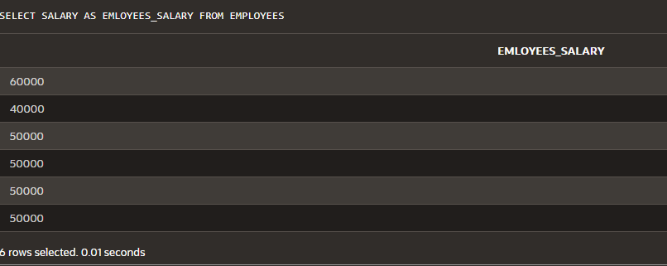

* **SELECT THE TABLE AND ALSO ARRANGING USING “ORDER….BY”:**
* SELECT * FROM EMPLOYEES ORDER BY EMPLOYEE_ID;

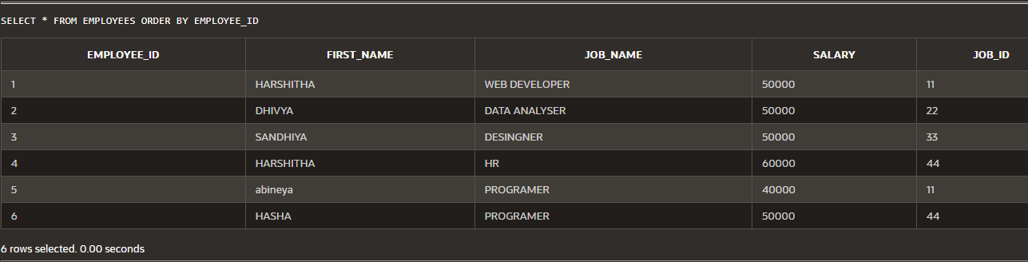

* ARRANGING THE TABLE IN Descending order:
* SELECT * FROM EMPLOYEES ORDER BY EMPLOYEE_ID DSEC;

**FORIGN KEY:**

**CREATE THE TABLE 1:**

* CREATE TABLE PERSON(PERSONAL_ID NUMBER(15) PRIMARY KEY, P_NAME VARCHAR(15), AGE INT(5),GENDER VARCHAR(10),ADDRESS VARCHAR(50));
* ALTER TABLE PERSON

ADD PRIMARY KEY(PERSON_ID);

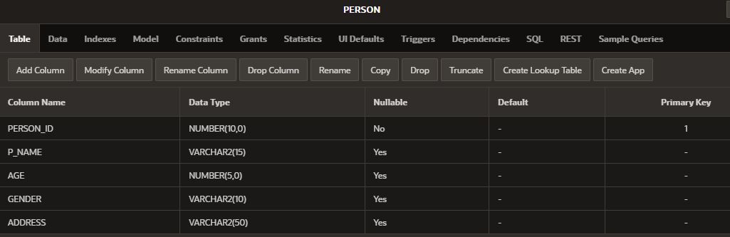

**CREATE THE TABLE 2:**

* CREATE TABLE P_ORDER(ORDER_ID NUMBER(10),PERSON_ID NUMBER(10), ITEM_NAME VARCHAR(15), ORDER_DATE NUMBER(5));
* ALTER TABLE PERSON

ADD PRIMARY KEY(OREDR_ID);

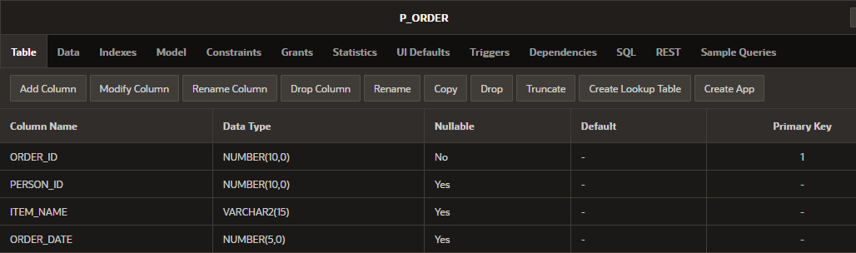

**SET THE FOREIGN KEY:**

* ALTER TABLE P_ORDER

ADD FOREIGN KEY(PERSON_ID) REFERENCES PERSON(PERSON_ID);

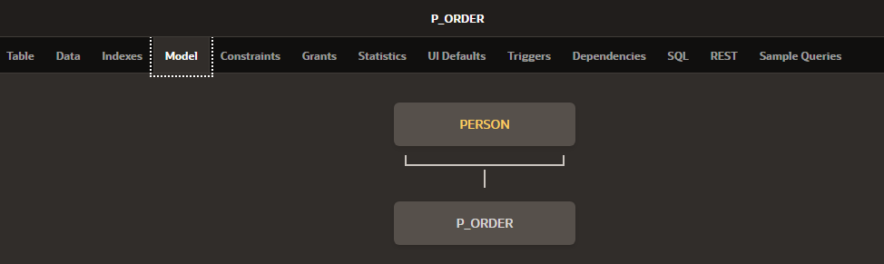

**CASE AND CONDITION:**

**CASE:**

* SELECT E_NAME, DEPARTMENT_NAME, DEPARTMENT_ID,

CASE SALARY

WHEN 30000 THEN 'DESIGNER'

WHEN 40000 THEN 'ANALYSER'

WHEN 60000 THEN 'WORKER'

ELSE 'OTHER DEPT.'

END AS "D_CASE"

FROM E_CASE;

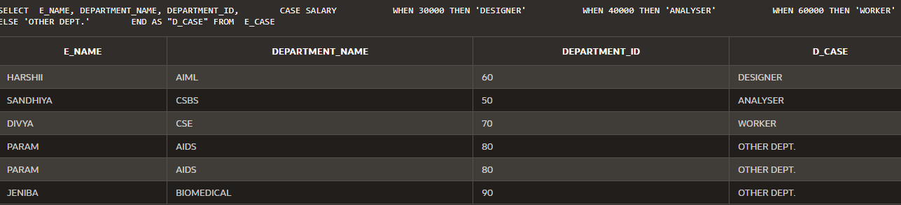

* **DECODE:**
* SELECT E_NAME,DEPARTMENT_NAME, SALARY,

DECODE(SALARY,

40000,'SALES',

60000,'AIML',

30000,'CSBS',

'UNKNOWN') AS D_CASE

FROM E_CASE;

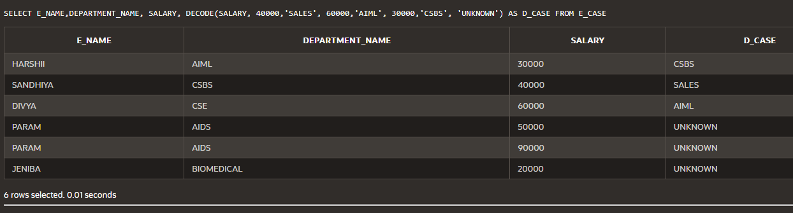

* **NATURAL JOIN:**
* SELECT E_NAME,DEPARTMENT_NAME, SALARY,EMPLOYEE_ID

FROM E_CASE NATURAL JOIN EMPLOYEES;

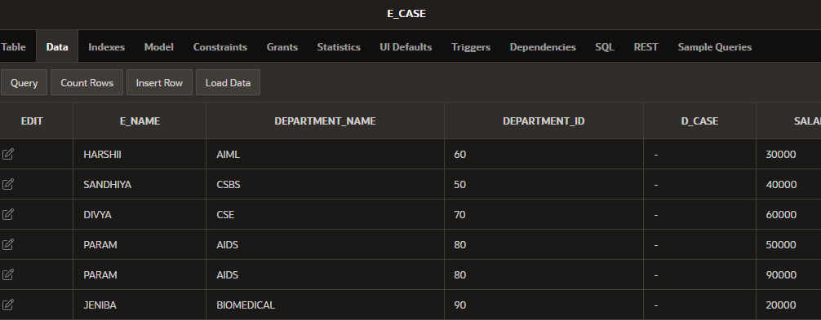

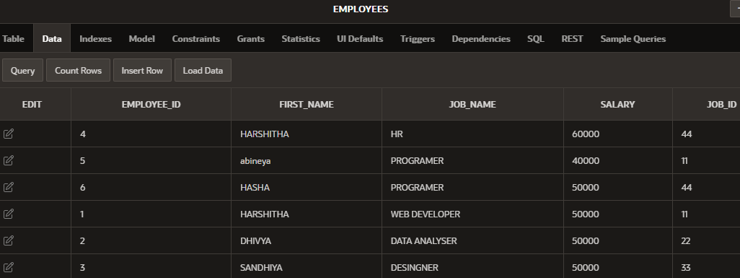

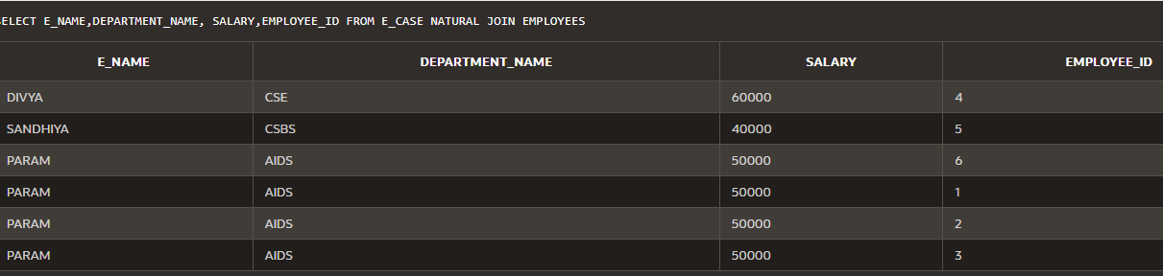

**JOIN THE TABLE USING CLAUSE:**

* SELECT EMPLOYEEE.LAST_NAME, DEP_ID, EMPLOYEEE.E_ID

FROM EMPLOYEEE

JOIN DEPARTMENT1

USING (DEP_ID);

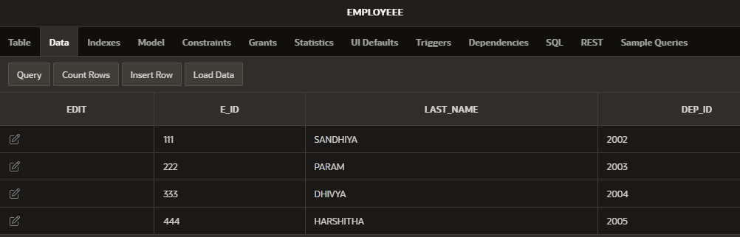

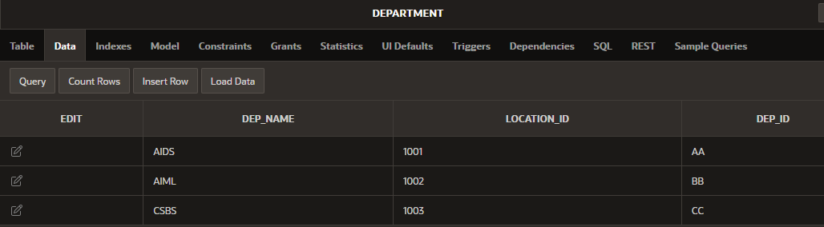

**OUTPUT:**

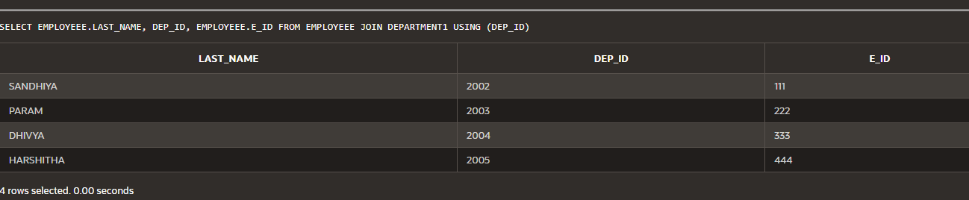

* **JOIN USING CONDITION:**
* SELECT EMPLOYEEE.LAST_NAME, DEP_ID, EMPLOYEEE.E_ID

FROM EMPLOYEEE

JOIN DEPARTMENT1

USING (DEP_ID)

WHERE DEP_ID >= 2003;

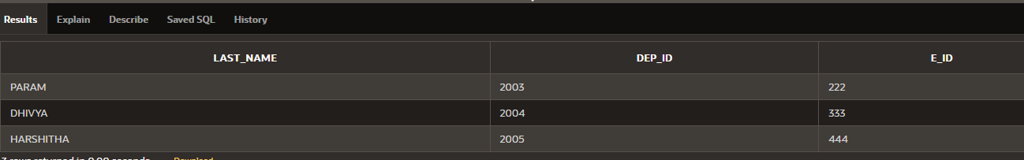

* **JOIN USING “ON”:**
* SELECT EMPLOYEEE.LAST_NAME,

EMPLOYEEE.DEP_ID AS DEPT_DEP_ID,

DEPARTMENT1.DEP_ID AS DEPT_DEP_ID,

EMPLOYEEE.E_ID

FROM EMPLOYEEE JOIN DEPARTMENT1

ON EMPLOYEEE.DEP_ID= DEPARTMENT1.DEP_ID;

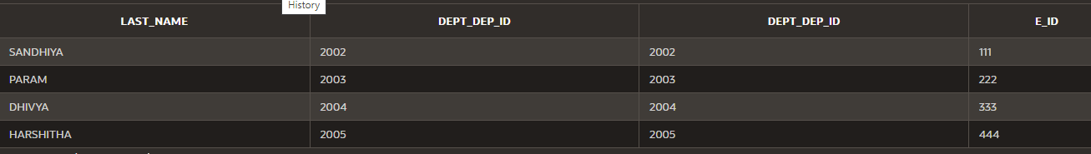

* **JOIN THE TWO TABLE USING WHERE CONDITION:**

SELECT EMPLOYEEE.LAST_NAME, DEP_ID, EMPLOYEEE.E_ID

FROM EMPLOYEEE

JOIN DEPARTMENT1

USING (DEP_ID)

WHERE EMPLOYEEE.LAST_NAME LIKE '%A';

* **LEFT OUTER JOIN:**
* SELECT e.LAST_NAME,d.DEP_ID

FROM EMPLOYEEE e LEFT OUTER JOIN

DEPARTMENT1 d ON(e.DEP_ID=d.DEP_ID);

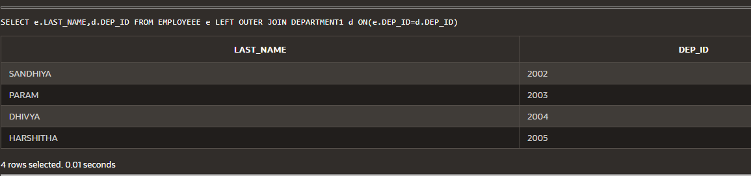

* **RIGHT OUTER JOIN**
* SELECT e.LAST_NAME,d.DEP_ID

FROM EMPLOYEEE e RIGHT OUTER JOIN

DEPARTMENT1 d ON(e.DEP_ID=d.DEP_ID);

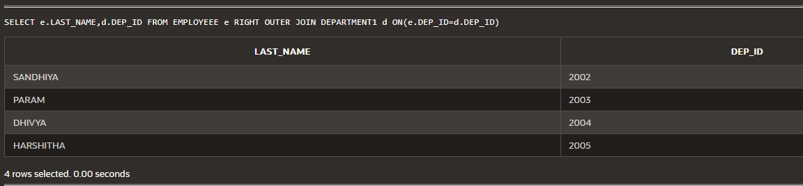

* **CROSS JOIN:**
* SELECT LAST_NAME,DEP_NAME

FROM EMPLOYEEE CROSS JOIN

DEPARTMENT1;

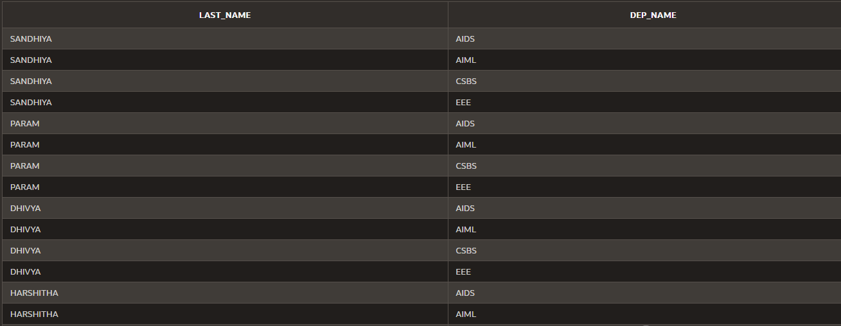

* **JOIN USING “||…” OPERATOR:**
* SELECT EMPLOYEEE.LAST_NAME||' WORKS FROM '||DEPARTMENT1.DEP_NAME

AS "WORKSFROM"

FROM EMPLOYEEE JOIN DEPARTMENT1

ON (EMPLOYEEE.DEP_ID=DEPARTMENT1.DEP_ID);

